**XGBoost Algorithm in Machine Learning**

[[Ambika](https://medium.com/@ambika199820?source=post_page-----2391edb101ce--------------------------------)](https://medium.com/@ambika199820?source=post_page-----2391edb101ce--------------------------------)

[Ambika](https://medium.com/@ambika199820?source=post_page-----2391edb101ce--------------------------------)

·

[Follow](https://medium.com/m/signin?actionUrl=https%3A%2F%2Fmedium.com%2F_%2Fsubscribe%2Fuser%2Fb7f0dfb3dc5a&operation=register&redirect=https%3A%2F%2Fmedium.com%2F%40ambika199820%2Fxgboost-algorithm-in-machine-learning-2391edb101ce&user=Ambika&userId=b7f0dfb3dc5a&source=post_page-b7f0dfb3dc5a----2391edb101ce---------------------post_header-----------)

5 min read

·

Aug 21, 2023

170

“***XGBoost, short for “Extreme Gradient Boosting,” is a popular and powerful machine learning algorithm that falls under the category of gradient boosting techniques. It is widely used for both classification and regression tasks. XGBoost enhances the traditional gradient boosting approach by incorporating various optimizations and regularization techniques, resulting in improved accuracy and efficiency.”***

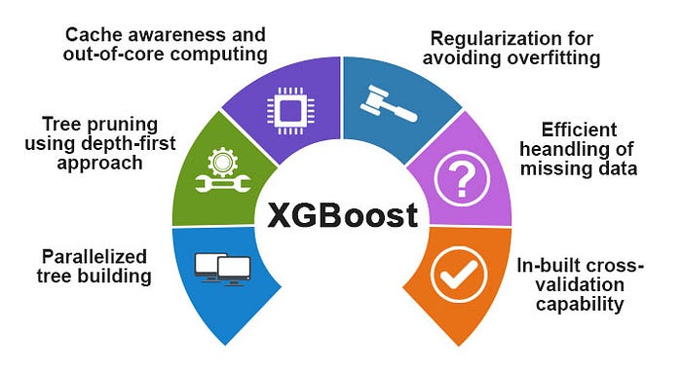

[source](https://www.educba.com/xgboost-algorithm/)

XGBoost is a versatile machine learning algorithm that finds applications in a wide range of domains. Some of its common uses and applications:

1. **Classification**: XGBoost is often employed for classification tasks, such as spam detection, image recognition, fraud detection, and sentiment analysis. Its ability to handle complex relationships and high-dimensional data makes it well-suited for these tasks.
2. **Regression**: XGBoost can also be used for regression problems, such as predicting housing prices, stock prices, or other continuous variables. It excels in capturing nonlinear relationships between input features and target variables.
3. **Ranking**: XGBoost can be used to create ranking models, where the goal is to order items according to their relevance. This is useful in search engines, recommendation systems, and personalized marketing.
4. **Anomaly Detection**: XGBoost can identify unusual patterns in data, making it useful for anomaly detection in areas like cybersecurity, network monitoring, and fraud detection.
5. **Time Series Forecasting**: XGBoost’s ability to capture temporal dependencies makes it suitable for time series forecasting, such as predicting stock prices, weather conditions, or demand for products.
6. **Natural Language Processing (NLP)**: XGBoost can be applied to NLP tasks, including text classification, sentiment analysis, and named entity recognition.
7. **Biomedical Research**: XGBoost has been used in bioinformatics and medical research for tasks like disease classification, drug discovery, and identifying biomarkers.
8. **Image Segmentation**: In computer vision, XGBoost can assist in tasks like image segmentation, where the goal is to partition an image into meaningful regions.
9. **Customer Churn Prediction**: XGBoost can help businesses predict customer churn by analyzing customer behavior patterns and predicting whether a customer is likely to stop using a product or service.
10. **Energy Consumption Prediction**: XGBoost can be used to predict energy consumption based on factors like weather conditions, time of day, and historical data.
11. **Financial Analysis**: XGBoost is used in financial analysis for credit scoring, risk assessment, and fraud detection.
12. **Environmental Monitoring**: XGBoost can analyze environmental data to predict pollution levels, water quality, and other environmental factors.

Overall, XGBoost’s adaptability, accuracy, and efficiency have made it a popular choice across a wide range of industries and domains for solving complex predictive modeling and decision-making problem.

Now lets check out the steps involved in XGBoost Algorithm

At its core, XGBoost is an ensemble learning algorithm that combines the predictions of multiple weak learners, usually decision trees, to create a strong predictive model. The intuition behind XGBoost involves optimization through gradient descent and boosting.

Simplified mathematical intuition of how XGBoost works:

1. **Gradient Boosting**: In boosting, each new model is built to correct the errors of the previous models. It’s a step-by-step approach to improve the model’s performance iteratively.
2. **Loss function**: XGBoost minimizes a loss function that measures the difference between predicted and actual values. Common loss functions include mean squared error (for regression) and log loss (for classification).
3. **Gradient Descent**: XGBoost uses gradient descent to minimize the loss function. It calculates the gradient of the loss with respect to the current model’s predictions.
4. **Additive Learning:** At each boosting iteration, a new decision tree (weak learner) is added to the ensemble. This tree is designed to minimize the residual errors of the previous trees.
5. **Weighted Updates**: XGBoost assigns weights to the data points. Data points that are harder to predict (with higher residual errors) are given greater weights, so the next model focuses on correcting those errors.
6. **Regularization**: XGBoost includes regularization terms (L1 and L2) to prevent overfitting. These terms penalize complex models and encourage simplicity.
7. **Learning Rate**: It introduces a “learning rate” parameter that controls the step size of each iteration. A smaller learning rate slows down the learning process, allowing for finer adjustments.
8. **Feature Importance:** XGBoost calculates feature importance scores by evaluating how much each feature contributes to reducing the loss function across all trees.
9. **Stopping Criteria**: It stops adding trees when a predefined stopping criterion is met, such as reaching a certain number of trees or when the improvement in the loss function becomes negligible.
10. **Prediction:** To make predictions, XGBoost combines the predictions of all the weak learners, each multiplied by a “shrinkage” factor (learning rate).

In summary, XGBoost builds an ensemble of decision trees that iteratively correct the errors of the previous trees. It does so by calculating gradients and using gradient descent to update the model’s parameters.

Using XGBoost comes with several advantages and disadvantages

Now lets discuss the Pros and Cons:

**Pros**

1. **High Accuracy**: XGBoost is known for its exceptional predictive accuracy. It often outperforms other machine learning algorithms on a wide range of tasks.
2. **Handling Nonlinearity**: XGBoost can capture complex relationships and interactions between features, making it suitable for datasets with nonlinear patterns.
3. **Feature Importance**: XGBoost provides insights into feature importance, helping us understand which features contribute the most to predictions.
4. **Regularization:**It includes built-in L1 (Lasso) and L2 (Ridge) regularization, which can help prevent overfitting and improve generalization.
5. **Missing Data Handling**: XGBoost can handle missing values in the data without requiring imputation.
6. **Parallel Processing**: It supports parallel and distributed computing, making it efficient for large datasets and boosting the training speed.

**7. Performance:** XGBoost is optimized for performance and memory usage, making it suitable for real-world applications and competitions.

**Cons:**

1. **Complexity**: Configuring XGBoost can be challenging due to its numerous hyperparameters. Choosing the right parameters requires experimentation and tuning.
2. **Computationally Intensive**: While parallel processing helps, training XGBoost can still be computationally intensive, especially for deep trees or large datasets.
3. **Overfitting Risk:** If not properly tuned, XGBoost can overfit the training data, especially when using deep trees and high learning rates.
4. **Black-Box Model:**Like most ensemble methods, the final prediction of XGBoost comes from a combination of multiple models, which can make the model interpretation complex.

**Conclusion:**

Due to its robustness, efficiency, and capability to handle complex relationships in data, XGBoost has become a popular choice for machine learning competitions and real-world applications. The algorithm’s ability to handle complex relationships, regularization, and feature importance analysis makes it a powerful tool for various machine learning tasks.

[Xgboost](https://medium.com/tag/xgboost?source=post_page-----2391edb101ce---------------xgboost-----------------)

[Data Science](https://medium.com/tag/data-science?source=post_page-----2391edb101ce---------------data_science-----------------)

[Machine Learning](https://medium.com/tag/machine-learning?source=post_page-----2391edb101ce---------------machine_learning-----------------)

[Statistics](https://medium.com/tag/statistics?source=post_page-----2391edb101ce---------------statistics-----------------)